Tunisia

## Freedom House political status

The data set shows the Freedom House political scores and status of the country each year.

## # A tibble: 19 x 5  
## country iso3c date mean status   
## <chr> <chr> <dbl> <dbl> <chr>   
## 1 Tunisia TUN 1996 5.5 Not Free   
## 2 Tunisia TUN 1998 5.5 Not Free   
## 3 Tunisia TUN 2000 5.5 Not Free   
## 4 Tunisia TUN 2002 5.5 Not Free   
## 5 Tunisia TUN 2003 5.5 Not Free   
## 6 Tunisia TUN 2004 5.5 Not Free   
## 7 Tunisia TUN 2005 5.5 Not Free   
## 8 Tunisia TUN 2006 5.5 Not Free   
## 9 Tunisia TUN 2007 6 Not Free   
## 10 Tunisia TUN 2008 6 Not Free   
## 11 Tunisia TUN 2009 6 Not Free   
## 12 Tunisia TUN 2010 6 Not Free   
## 13 Tunisia TUN 2011 3.5 Partly Free  
## 14 Tunisia TUN 2012 3.5 Partly Free  
## 15 Tunisia TUN 2013 3 Partly Free  
## 16 Tunisia TUN 2014 2 Free   
## 17 Tunisia TUN 2015 2 Free   
## 18 Tunisia TUN 2016 2 Free   
## 19 Tunisia TUN 2017 2.5 Free

## Freedom House classification of political change

The data set shows the GDP growth and the ecomic growth classification of the country each year.

## # A tibble: 19 x 4  
## country iso3c date politicalChangeFH  
## <chr> <chr> <dbl> <chr>   
## 1 Tunisia TUN 1996 no change   
## 2 Tunisia TUN 1998 no change   
## 3 Tunisia TUN 2000 no change   
## 4 Tunisia TUN 2002 no change   
## 5 Tunisia TUN 2003 no change   
## 6 Tunisia TUN 2004 no change   
## 7 Tunisia TUN 2005 no change   
## 8 Tunisia TUN 2006 no change   
## 9 Tunisia TUN 2007 autocratization   
## 10 Tunisia TUN 2008 no change   
## 11 Tunisia TUN 2009 no change   
## 12 Tunisia TUN 2010 no change   
## 13 Tunisia TUN 2011 democratization   
## 14 Tunisia TUN 2012 no change   
## 15 Tunisia TUN 2013 democratization   
## 16 Tunisia TUN 2014 democratization   
## 17 Tunisia TUN 2015 no change   
## 18 Tunisia TUN 2016 no change   
## 19 Tunisia TUN 2017 autocratization

## Freedom House score trend

The plot shows the Freedom House scores trend of the country.

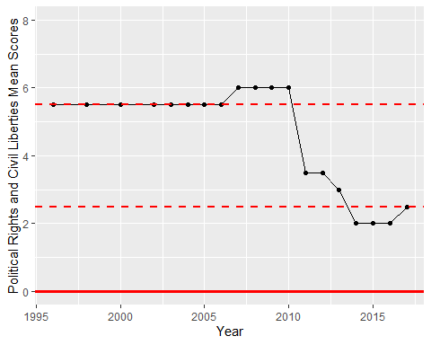

Freedom House Score Trend